Supporting Information

Chiral phosphine Lewis base catalyzed asymmetric aza-Baylis-Hillman reaction of N-sulfonated imines with methyl vinyl ketone and phenyl acrylate

Min Shi* and Lian-Hui Chen

State Key Laboratory of Organometallic Chemistry,
Shanghai Institute of Organic Chemistry,
Chinese Academy of Sciences,354 Fenglin Lu, Shanghai 200032 China,
mshi@pub.sioc.ac.cn, Fax: 86-21-64166128

Optimized reaction condition for the aza-Baylis-Hillman reaction of N-sulfonated imine 1e with MVK.
The results were summarized in Table 1. At 0 ºC~20 ºC (room temperature), high enantiomeric excesses (80%~90% ee) of the corresponding aza-Baylis-Hillman adduct 1e with S configuration were achieved in good yields in THF, Et₂O or CH₂Cl₂ (Table 1, entries 1, 3-4, 6, and 9). The coexistence of Lewis acid [Ti(OPr^{i})₄] improved the yield of 1e, but did not significantly affect the ee of 1e (Table 1, entry 2). Moreover, at lower temperature (-30 ºC), the ee of 1e can reach 94% in 70% yield (Table 1, entry 4). However, when the reactions were carried out in toluene, MeCN or DMF, the aza-Baylis-Hillman adduct 1e was obtained with lower ee in lower yields (Table 1, entries 7, 8, and 10-11).

The aza-Baylis-Hillman reaction of N-sulfonated aliphatic imine with MVK (Scheme 2).

Optimized reaction conditions of aza-Baylis-Hillman reaction of N-sulfonated imine 1e with phenyl acrylate.

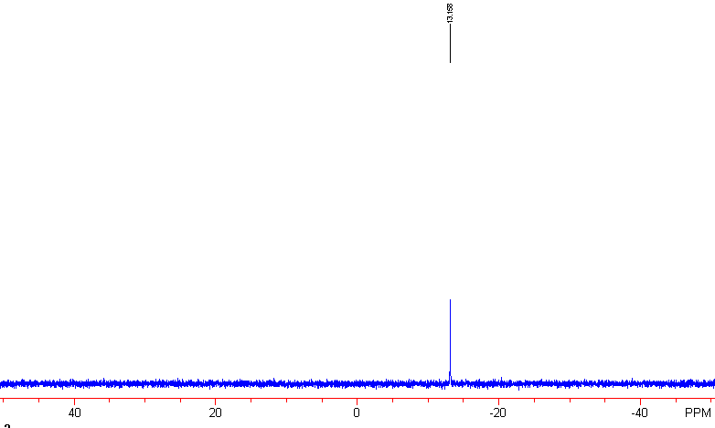
Figure 1. The ³¹P NMR chart of L1 in CDCl₃.

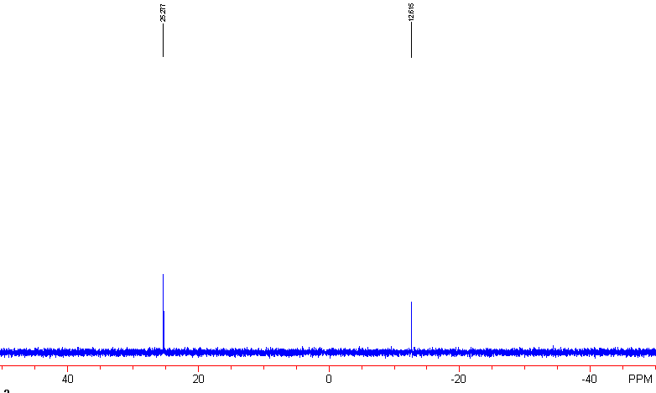
Figure 2. The ³¹P NMR chart of L1 with MVK and N-sulfonated imine in CDCl₃.

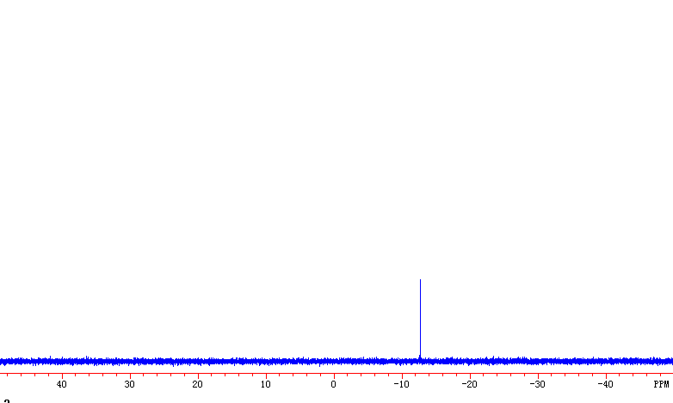
Figure 3. The ³¹P NMR chart of L2 (MOP) in CDCl₃

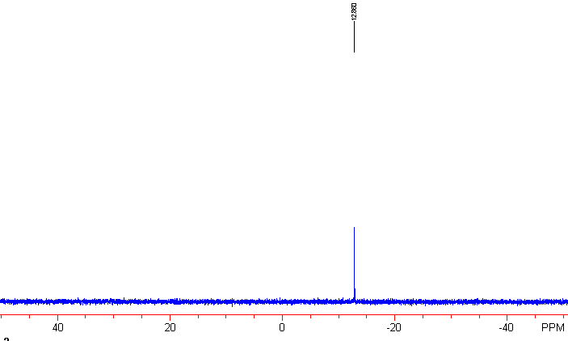
Figure 4. The ³¹P NMR chart of L2 (MOP) with MVK and imine (molar ration= 1:5).

Experimental Section
General Remarks. MPs were obtained with a Yanagimoto micro melting point apparatus and are uncorrected. ¹H NMR spectra were recorded on a Bruker AM-300 spectrometer as a solution in CDCl₃ with tetramethylsilane (TMS) as an internal standard; J-values are in Hz. Mass spectra were recorded with a HP-5989 instrument. N-Tosylimines were prepared according to the literature.¹ The chiral phosphine catalyst was prepared according to the literature.² All of the solid compounds reported in this paper gave satisfactory CHN microanalyses with a Carlo-Erba 1106 analyzer. Commercially obtained reagents were used without further purification. All reactions were monitored by TLC with Huanghai GF₂₅₄ silica gel coated plates. Flash Column Chromatography was carried out using 200-300 mesh silica gel at increased pressure. The optical purities of the Baylis-Hillman adducts were determined by HPLC analysis using a chiral stationary phase column (column, Daicel Co. Chiralcel AD, AS, TBB and OJ; eluent: hexane/2-propanol mixture; flow rate, 0.7 mL min⁻¹; detection, 254 nm or 220 nm light) and the absolute configuration of the major enantiomer was assigned according to the sign of the specific rotation.

Typical Reaction Procedure for (R)-2’-Diphenylphosphanyl-[1,1’]binaphthalenyl-2-ol (L1) Catalyzed Baylis-Hillman Reaction of N-(Benzylidene)-4-methylbenzenesulfonamide with Methyl Vinyl Ketone (MVK).
A 100 mL Schlenk tube contained with N-(benzylidene)-4-methylbenzenesulfonamide (0.5 mmol) and (R)-2’-diphenylphosphanyl-[1,1’]binaphthalenyl-2-ol (L1) (23 mg, 0.05 mmol) was degassed and the reaction vessel was protected under argon atmosphere. Then, THF (1.0 mL) was added. After the reaction mixture was cooled to -30 °C, methyl vinyl ketone (MVK) (125 uL, 1.5 mmol) was added into the Schlenk tube. The reaction mixture was stirred at -30 °C for 12-36 h. The solvent was removed under reduced pressure and the residue was purified by flash column chromatography (SiO₂, eluent: EtOAc/Petroleum ether = 1/5) to yield the corresponding Baylis-Hillman adduct as a colorless solid which was immediately subjected to the chiral HPLC for the analysis of the achieved enantiomeric excess. For microanalysis, all these products were recrystallized from acetone and n-hexane.
4-Methyl-N-(2-methylene-3-oxo-1-phenylbutyl)benzenesulfonamide 1a (C₆H₅): a colorless solid, 81 mg, yield: 49%. Mp. 124-126 ºC; [α]_{D}²⁰ = +28.3° (c = 0.95, CHCl₃). IR (CHCl₃): ν 1667 cm⁻¹ (C=O). ¹H NMR (CDCl₃, TMS, 300 MHz): δ 2.16 (3H, s, Me), 2.42 (3H, s, Me), 5.26 (1H, d, J = 8.6 Hz), 5.61 (1H, d, J = 8.6 Hz), 6.10 (1H, s), 6.11 (1H, s), 7.11 (2H, m, Ar), 7.20-7.27 (5H, m, Ar), 7.66 (2H, d, J = 8.1 Hz, Ar). MS (EI): m/e 260 (M⁺-69, 14.09), 174 (M⁺-155, 100), 155 (SO₂PhMe⁺, 29.60). Anal. Calcd for C₁₈H₁₉NO₃S. C, 65.63%, H, 5.81%, N, 4.25%. found: C, 65.64%, H, 5.74%, N, 4.14%. HPLC: AD column; λ = 254 nm; eluent: Hexane/Isopropanol = 80/20; Flow rate: 0.7 mL/min; t_{major} = 17.14 min, t_{minor} = 18.80 min; ee% = 82%.
4-Methyl-N-(2-methylene-3-oxo-1-p-tolylbutyl)benzenesulfonamide 1b (p-CH₃): a colorless solid, 90 mg, yield: 53%. Mp: 114-116 ºC; [α]_{D}²⁰ = +38.4° (c = 1.06, CHCl₃). IR (KBr): ν 1664 cm⁻¹ (C=O). ¹H NMR (CDCl₃, TMS, 300 MHz): δ 2.16 (3H, s, Me), 2.27 (3H, s, Me), 2.42 (3H, s, Me), 5.23 (1H, d, J = 8.4 Hz), 5.56 (1H, d, J = 8.4 Hz), 6.10 (2H, s), 6.95 (2H, d, J = 8.2 Hz, Ar), 7.00 (2H, d, J = 8.2 Hz, Ar), 7.24 (2H, d, J = 8.2 Hz, Ar), 7.65 (2H, d, J = 8.2 Hz, Ar). MS (EI): m/e 274 (M⁺-69, 4.44), 188 (M⁺-155, 100), 91 (PhMe⁺, 50.98). Anal. Calcd for C₁₉H₂₁NO₃S. C, 66.47%, H, 6.12%, N, 4.08%; found: C, 66.74%, H, 6.47%, N, 3.89%. HPLC: AD column; λ = 254 nm; eluent: Hexane/Isopropanol = 80/20; Flow rate: 0.7 mL/min; t_{major} = 17.42 min, t_{minor} = 18.81 min; ee% = 80%.
N-[1-(4-Ethylphenyl)-2-methylene-3-oxobutyl]-4-methylbenzenesulfonamide 1c (p-C₂H₅): a colorless solid, 110 mg, yield: 62%. Mp: 110-114 ºC; [α]_{D} ²⁰ = +38.4° (c = 1.05, CHCl₃). IR (CHCl₃): ν 1674 cm⁻¹ (C=O). ¹H NMR (CDCl₃, TMS, 300 MHz): δ 1.23 (3H, t, J = 7.6 Hz, Me), 2.15 (3H, s, Me), 2.39 (3H, s, Me), 2.54 (2H, q, J = 7.6 Hz, CH₂), 5.20 (1H, d, J = 6.1 Hz, NH), 5.51 (1H, d, J = 8.4 Hz, CH), 6.09 (2H, s), 6.97 (2H, d, J = 6.1 Hz, Ar), 6.98 (2H, J = 6.1 Hz, Ar), 7.21 (2H, d, J = 8.4 Hz, Ar), 7.63 (2H, d, J = 8.4 Hz); MS (EI): m/e 358 (M⁺-1, 0.5), 288 (M⁺-69, 5.6), 202 (M⁺-155, 100); Anal. Calcd for C₂₀H₂₃NO₃S. C, 67.20%, H, 6.49%, N, 3.92%. found: C, 67.04%, H, 6.42%, N, 3.74%. HPLC: TBB column; λ = 254 nm; eluent: Hexane/Isopropanol = 80/20; Flow rate: 0.7 mL/min; t_{minor} = 10.84 min; t_{major} = 11.52 min, ee% = 76%.
N-[1-(4-Methoxyphenyl)-2-methylene-3-oxobutyl]-4-methylbenzenesulfonamide 1d (p-OCH₃): a colorless solid, 74 mg, yield: 41%. Mp: 120-122 ºC; [α]_{D}²⁰ = +17.5° (c = 1.08, CHCl₃). IR (CHCl₃): ν 1675 cm⁻¹ (C=O). ¹H NMR (CDCl₃, TMS, 300 MHz): δ 2.17 (3H, s, Me), 2.41 (3H, s, Me), 3.74 (3H, s, Me), 5.21 (1H, d, J = 8.3 Hz, NH), 5.49 (1H, d, J = 8.3 Hz, CH), 6.10 (2H, s), 6.73 (2H, d, J = 6.8 Hz, Ar), 6.99 (2H, d, J = 6.8 Hz, Ar), 7.25 (2H, d, J = 9.3 Hz, Ar), 7.65 (2H, d, J = 9.3 Hz, Ar). MS (EI): m/e 359 (M⁺, 0.30), 290 (M⁺-69, 9.61), 204 (M⁺-155, 100), 91 (PhMe⁺, 45.58). Anal. Calcd for C₁₉H₂₁NO₄S. C, 63.49%, H, 5.89%, N, 3.90%; found: C, 63.24%, H, 5.81%, N, 3.73%. HPLC: TBB column; λ = 220 nm; eluent: Hexane/Isopropanol/TBME = 75/5/20; Flow rate: 0.7 mL/min; t_{minor} = 11.83 min; t_{major} = 12.67 min, ee% = 29%.
N-[1-(4-Fluorophenyl)-2-methylene-3-oxobutyl]-4-methylbenzenesulfonamide 1e (p-F): a colorless solid, 146 mg, yield: 84%. Mp: 104-106 ºC. [α]_{D}²⁰ = +22.1° (c = 1.2, CHCl₃). IR (KCl): ν 3255 cm⁻¹ (N-H), 1663.3 cm⁻¹ (C=O). ¹H NMR (CDCl₃, TMS, 300 MHz): δ 2.15 (3H, s, Me), 2.41(3H, s, Me), 5.24(1H, d, J = 8.7 Hz), 5.75 (1H, d, J = 8.7 Hz), 6.07 (1H, s), 6.09 (1H, s), 6.84-6.9 (2H, dd, J₁ = 9.0 Hz, J₂ = 8.6 Hz), 7.04-7.09 (2H, dd, J₁ = 8.6 Hz, J₂ = 5.2 Hz), 7.23 (2H, d, J = 8.1 Hz), 7.63 (2H, J = 8.1 Hz), MS (EI): m/e 192 (M⁺-155, 8.79), 155 (M⁺-192, 7.08), 95 (M⁺-155-97, 11.72), 91 (M⁺-192-64, 70.98), 65 (M⁺-155-64-26, 45.32), 43 (M⁺-304, 100). Anal. Calcd for C₁₈H₁₈FNO₃S: C, 62.24%, H, 5.22%, N, 4.03%. found: C, 61.98%, H, 5.29%, N, 4.04%. HPLC: AD column; λ = 254 nm; eluent: Hexane/Isopropanol = 70/30; Flow rate: 0.7 mL/min; t_{major} = 13.15 min, t_{minor} = 14.26 min; ee% = 81%.
N-[1-(4-Chlorophenyl)-2-methylene-3-oxobutyl]-4-methylbenzenesulfonamide 1f (p-Cl): a colorless solid, 131 mg, yield: 72%. Mp: 89-92 ºC; [α]_{D} ²⁰ = +25.3° (c = 1.065, CHCl₃). IR (CHCl₃): ν 1674 cm⁻¹ (C=O); ¹H NMR (CDCl₃, TMS, 300 MHz): δ 2.11 (3H, s, Me), 2.38 (3H, s, Me), 5.24 (1H, d, J = 9.1Hz, NH), 5.99 (1H, d, J = 9.1 Hz, CH), 6.03 (1H, s), 6.06 (1H, s,), 7.01 (2H, d, J = 8.6Hz, Ar), 7.12 (2H, d, J = 8.6Hz, Ar), 7.19 (2H, d, J = 8.1 Hz, Ar), 7.59 (2H, d, J = 8.1Hz, Ar). MS (EI): m/e: 294 (M⁺-69, 2.36), 208 (M⁺-155, 100), 91 (PhMe⁺, 39.81). Anal. Calcd for C₁₈H₁₈ClNO₃S. C, 59.42%, H, 4.99%, N, 3.85%; found: C, 59.43%, H, 4.94%, N, 3.78 %. HPLC: AS column; λ = 254 nm; eluent: Hexane/Isopropanol = 65/35; Flow rate: 0.7 mL/min; t_{major} = 24.437 min, t_{minor} = 32.41 min; ee% = 94%.
N-[1-(4-Bromophenyl)-2-methylene-3-oxobutyl]-4-methylbenzenesulfonamide 1g (p-Br): a colorless solid, 173 mg, yield: 85%. Mp: 98-100 ºC. [α]_{D}²⁰ = +27.8° (c = 1.075, CHCl₃). IR (KCl): ν 3295 cm⁻¹ (N-H), 1669.5 cm⁻¹ (C=O). ¹H NMR (CDCl₃, TMS, 300 MHz): δ 2.15 (3H, s, Me), 2.41 (3H, s, Me), 5.19 (1H, d, J = 9.1 Hz), 5.71 (1H, d, J = 9.1 Hz), 6.06 (1H, s), 6.09 (1H, s), 6.98 (2H, d, J = 7.8 Hz), 7.26 (2H, d, J = 8.0 Hz), 7.31 (2H, dd, J₁ = 7.8 Hz, J₂ = 2.0 Hz), 7.62 (2H, J = 8.0 Hz), MS (EI): m/e 254 (M⁺+2-155, 10.96), 252 (M⁺-155, 10.67), 208 (M⁺-155-44, 3.87), 184 (M⁺-155-68, 9.58), 155 (M⁺-253, 15.5), 130 (M⁺-155-43-79, 47.22), 91 (M⁺-252-64, 100), 65 (M⁺-252-64-26, 47.08), 43 (M⁺-365, 74.05). Anal. Calcd. for C₁₈H₁₈BrNO₃S: C, 52.95%, H, 4.44%, N, 3.43%. found: C, 53.12%, H, 4.60%, N, 3.33%. HPLC: AD column; λ = 254 nm; eluent: Hexane/Isopropanol = 80/20; Flow rate: 0.7 mL/min; t_{major} = 23.16 min, t_{minor} = 25.65 min; ee% = 83%.
N-[1-(3-Fluorophenyl)-2-methylene-3-oxobutyl]-4-methylbenzenesulfonamide 1h (m-F): a colorless solid, 45 mg, yield: 26%. Mp: 109-111 ºC; [α]_{D}²⁰ = +10.6° (c = 1.03, CHCl₃). IR (CHCl₃): ν 1673 cm⁻¹ (C=O). ¹H NMR (CDCl₃, TMS, 300 MHz): δ 2.16 (3H, s, Me), 2.41 (3H, s, Me), 5.24 (1H, d, J = 9.2 Hz, NH), 5.78 (1H, d, J = 9.2 Hz), 6.06 (1H, s), 6.11 (1H, s), 6.79-6.92 (3H, m, Ar), 7.14-7.23 (3H, m, Ar), 7.65 (2H, d, J = 8.6 Hz, Ar). MS (EI): m/e 278 (M⁺-69, 7.84), 192 (M⁺-155, 100), 155 (SO₂PhMe⁺, 44.33). Anal. Calcd. for C₁₈H₁₈FNO₃S. C, 62.23%, H, 5.22%, N, 4.03%; found: C, 62.38%, H, 5.34%, N, 3.82%. HPLC: AD column; λ = 254 nm; eluent: Hexane/Isopropanol = 80/20; Flow rate: 0.7 mL/min; t_{major} = 17.65 min, t_{minor} = 18.11 min; ee% = 91%.
N-[1-(3-Chlorophenyl)-2-methylene-3-oxobutyl]-4-methylbenzenesulfonamide 1i (m-Cl): a colorless solid, 112 mg, yield: 62%. Mp: 89-92 ºC. [α]_{D}²⁰ = +17.5° (c = 1.12, CHCl₃). IR (KCl): ν 3305 cm⁻¹ (N-H), 1667 cm⁻¹ (C=O). ¹H NMR (CDCl₃, TMS, 300 MHz): δ 2.16 (3H, s, Me), 2.41(3H, s, Me), 5.20 (1H, d, J = 9.0 Hz), 5.69 (1H, d, J = 9.0 Hz), 6.08 (1H, s), 6.12 (1H, s), 7.0-7.03 (2H, m), 7.13-7.15 (2H, m), 7.24 (2H, d, J = 8.2 Hz), 7.63 (2H, J = 8.2 Hz), MS (EI): m/e 208 (M⁺-155, 7.61), 155 (M⁺-208, 9.04), 91 (M⁺-208-64, 76.55), 65 (M⁺-208-64-26, 44.72), 43 (M⁺-360, 100). Anal. Calcd. for C₁₈H₁₈ClNO₃S: C, 59.42%, H, 4.98%, N, 3.85%. found: C, 59.49%, H, 5.17%, N, 3.81%. HPLC: AD column; λ = 254 nm; eluent: Hexane/Isopropanol = 70/30; Flow rate: 0.7 mL/min; t_{major} = 17.65 min, t_{minor} = 20.81 min; ee% = 88%.
4-Methyl-N-[2-methylene-1-(4-nitrophenyl)-3-oxobutyl]benzenesulfonamide 1j (p-NO₂): a colorless solid, 110 mg, yield: 60%. Mp: 120-122 ºC; [α]_{D}²⁰ = +2.5° (c = 0.975, CHCl₃). IR (CHCl₃): ν 1674 cm⁻¹ (C=O). ¹H NMR (CDCl₃, TMS, 300 MHz): δ 2.15 (3H, s, Me), 2.44 (3H, s, Me), 5.32 (1H, d, J = 9.4 Hz), 5.94 (1H, d, J = 9.4 Hz), 6.08 (1H, s), 6.14 (1H, s), 7.25 (2H, d, J = 8.3Hz, Ar), 7.34 (2H, d, J = 8.7Hz, Ar), 7.65 (2H, d, J = 8.3Hz, Ar), 8.07 (2H, d, J = 8.7Hz). MS (EI): m/e 305 (M⁺-69, 3.77), 219 (M⁺-155, 100), 155 (SO₂PhMe⁺, 29.96). Anal. Calcd. for C₁₈H₁₈N₂O₅S. C, 57.74%, H, 4.85%, N, 7.48%; found: C, 57.62%, H, 4.84%, N, 7.39%. HPLC: OJ column; λ = 254 nm; eluent: Hexane/Isopropanol = 60/40; Flow rate: 0.7 mL/min; t_{major} = 13.15 min, t_{minor} = 14.26 min; ee% = 94%.
4-Methyl-N-[2-methylene-1-(3-nitrophenyl)-3-oxobutyl]benzenesulfonamide 1k (m-NO₂): a colorless solid, 101 mg, yield: 54%. Mp: 122-124 ºC. [α]_{D}²⁰ = +10.1° (c = 1.04, CHCl₃). IR (KCl): ν 3317 cm⁻¹ (N-H), 1671.2 cm⁻¹ (C=O). ¹H NMR (CDCl₃, TMS, 300 MHz): δ 2.18 (3H, s, Me), 2.41(3H, s, Me), 5.32 (1H, d, J = 9.4 Hz), 5.89 (1H, d, J = 9.4 Hz), 6.12 (1H, s), 6.18 (1H, s), 7.25 (2H, d, J = 8.6 Hz), 7.44 (1H, dd, J₁ = 8.2 Hz, J₂ = 7.8 Hz), 7.61 (1H, d, J = 7.8 Hz), 7.65 (2H, d, J = 8.6 Hz), 7.89 (1H, s), 8.05 (1H, d, J = 8.2 Hz), MS (EI): m/e 91 (M⁺-283, 52.79), 65 (M⁺-283-26, 37.97), 43 (M⁺-331, 100). Anal. Calcd. for C₁₈H₁₈N₂O₅S: C, 57.74%, H, 4.84%, N, 7.48%. found: C, 57.74%, H, 5.07%, N, 7.34%. HPLC: AD column; λ = 254 nm; eluent: Hexane/Isopropanol = 80/20; Flow rate: 0.7 mL/min; t_{major} = 23.60 min, t_{minor} = 29.04 min; ee% = 90%.

Typical Reaction Procedure for (R)-2’-Diphenylphosphanyl-[1,1’]binaphthalenyl-2-ol (L1) Catalyzed Baylis-Hillman Reaction of Phenyl Acrylate with N-(Benzylidene)-4-methylbenzenesulfonamide.
A 100 mL Schlenk tube contained with N-(benzylidene)-4-methylbenzenesulfonamide (0.5 mmol) and (R)-2’-diphenylphosphanyl-[1,1’]binaphthalenyl-2-ol (L1) (23 mg, 0.05 mmol) was degassed and the reaction vessel was protected under argon atmosphere. Then, CH₂Cl₂ (2.0 mL) was added. After the mixtures were heated to 40 °C, phenyl acrylate (100 uL, 0.75 mmol) was added into the Schlenk tube. The reaction mixture was stirred at 40 °C for 12 h. The solvent was removed under reduced pressure and the residue was purified by flash column chromatography (SiO₂, eluent: EtOAc/Petroleum ether = 1/8) to yield the corresponding Baylis-Hillman adduct as a colorless solid which was immediately subjected to the chiral HPLC for the analysis of the achieved enantiomeric excess. For microanalysis, all these products were recrystallized from EtOAc and n-hexane.
2-[Phenyl-(toluene-4-sulfonylamino)-methyl]-acrylic acid phenyl ester 2a (C₆H₆): a colorless solid, 170 mg, yield: 84%. Mp: 110-112 ºC. [α]_{D}²⁰ = +0.4° (c = 1.01, CHCl₃). IR (KCl): ν 3300 cm⁻¹ (N-H), 1724.2 cm⁻¹ (C=O). ¹H NMR (CDCl₃, TMS, 300 MHz): δ 2.42 (3H, s, Me), 5.41 (1H, d, J = 8.6 Hz), 5.55 (1H, d, J = 8.6 Hz), 6.08 (1H, s), 6.50 (1H, s), 6.83-6.86 (2H, m), 7.15-7.35 (10H, m), 7.71 (2H, d, J = 8.1 Hz). MS (EI): m/e 314 (M⁺-93, 36.26), 260 (M⁺-93-54, 30.46), 155 (M⁺-252, 65.23), 143 (M⁺-93-171, 84.77), 115 (M⁺-93-171-28, 39.57), 91 (M⁺-316, 100), 77 (M⁺-330, 22.85), 65 (M⁺-316-26, 52.65). Anal. Calcd. for C₂₃H₂₁NO₄S: C, 67.80%, H, 5.19%, N, 3.44%. found: C, 67.83%, H, 5.40%, N, 3.32%. HPLC: AS column; λ = 254 nm; eluent: Hexane/Isopropanol = 60/40; Flow rate: 0.7 mL/min; t_{major} = 23.04 min, t_{minor} = 31.4 min; ee% = 61%.
2-[(4-Ethylphenyl)-(toluene-4-sulfonylamino)-methyl]-acrylic acid phenyl ester 2b (p-C₂H₅): a colorless solid, 130 mg, yield: 60%. Mp: 96-98 ºC. [α]_{D}²⁰ = +8.6° (c = 1.16, CHCl₃). IR (KCl): ν 3318 cm⁻¹ (N-H), 1732.4 cm⁻¹ (C=O). ¹H NMR (CDCl₃, TMS, 300 MHz): δ 1.19 (3Η, t, J = 7.5 Hz), 2.41 (3H, s), 2.57 (2H, q, J = 7.5 Hz), 5.38 (1H, d, J = 8.5 Hz), 5.58 (1H, d, J = 8.5 Hz), 6.08 (1H, s), 6.49 (1H, s), 6.86 (2H, d, J = 7.8 Hz), 7.06 (4H, s), 7.19-7.26 (3H, m), 7.32 (2H, t, J = 7.8 Hz), 7.7 (2H, d, J = 8.3 Hz). MS (EI): m/e 342 (M⁺-93, 31.65), 288 (M⁺-93-54, 23.94), 171 (M⁺-264, 100), 155 (M⁺-280, 31.89), 91 (M⁺-280-64, 68.19), 65 (M⁺-280-64-26, 26.26), Anal. Calcd. for C₂₅H₂₅NO₄S: C, 68.94%, H, 5.78%, N, 3.22%. found: C, 68.91%, H, 5.80%, N, 3.09%. HPLC: AS column; λ = 254 nm; eluent: Hexane/Isopropanol = 60/40; Flow rate: 0.7 mL/min; t_{major} = 18.98 min, t_{minor} = 27.39 min; ee% = 53%.
2-[(4-Fluorophenyl)-(toluene-4-sulfonylamino)-methyl]-acrylic acid phenyl ester 2c (p-F): a colorless solid, 170 mg, yield: 80%. Mp: 119-122 ºC. [α]_{D} ²⁰ = -1.6° (c = 1.03, CHCl₃). IR (KCl): ν 3297 cm⁻¹ (N-H), 1721.2 cm⁻¹ (C=O). ¹H NMR (CDCl₃, TMS, 300 MHz): δ 2.43 (3H, s, Me), 5.38 (1H, d, J = 8.8 Hz), 5.53 (1H, d, J = 8.8 Hz), 6.05 (1H, s), 6.49 (1H, s), 6.86-6.89 (2H, m), 6.91-6.97 (2H, t, J = 8.6 Hz), 7.14-7.18 (2H, m), 7.22-7.28 (3H, m), 7.31-7.36 (2H, dd, J₁= 7.3 Hz, J₂ = 8.2 Hz), 7.7 (2H, d, J = 8.1 Hz). MS (EI): m/e 332 (M⁺-93, 66.78), 278 (M⁺-93-54, 37.48), 161 (M⁺-93-171, 90.79), 155 (M⁺-270, 95.58), 133 (M⁺-93-171-28 , 42.46), 91 (M⁺-270-64, 100), 65 (M⁺-270-64-26, 30.55). Anal. Calcd. for C₂₃H₂₀FNO₄S: C, 64.93%, H, 4.74%, N, 3.29%. found: C, 65.00%, H, 4.96%, N, 3.21%. HPLC: AS column; λ = 254 nm; eluent: Hexane/Isopropanol = 60/40; Flow rate: 0.7 mL/min; t_{major} = 27.03 min, t_{minor} = 38.93 min; ee% = 69%.
2-[(4-Chlorophenyl)-(toluene-4-sulfonylamino)-methyl]-acrylic acid phenyl ester 2d (p-Cl): a colorless solid, 208 mg, yield: 94%. Mp: 120-122 ºC. [α]_{D}²⁰ = +3.4° (c = 0.97, CHCl₃). IR (KCl): ν 3296 cm⁻¹ (N-H), 1720.8 cm⁻¹ (C=O). ¹H NMR (CDCl₃, TMS, 300 MHz): δ 2.44 (3H, s, Me), 5.38 (1H, d, J = 9.0 Hz), 5.64 (1H, d, J = 9.0 Hz), 6.05 (1H, s), 6.50 (1H, s), 6.87-6.90 (2H, m), 7.12-7.16 (2H, m), 7.20-7.28 (5H, m), 7.33-7.38 (2H, m), 7.69-7.71 (2H,m). MS (EI): m/e 348 (M⁺-93, 30.24), 294 (M⁺-93-54, 19.66), 177 (M⁺-93-171, 65.22). 155 (M⁺-286, 81.92), 115 (M⁺-93-170-28-35, 33.60), 91 (M⁺-350, 100), 65 (M⁺-350-26, 50.99). Anal. Calcd. for C₂₃H₂₀ClNO₄S: C, 62.51%, H, 4.56%, N, 3.17%. found: C, 62.48%, H, 4.56%, N, 3.12%. HPLC: AS column; λ = 254 nm; eluent: Hexane/Isopropanol = 60/40; Flow rate: 0.7 mL/min; t_{major} = 21.4 min, t_{minor} = 28.9 min; ee% = 67%.
2-[(4-Bromophenyl)-(toluene-4-sulfonylamino)-methyl]-acrylic acid phenyl ester 2e (p-Br): a colorless solid, 206 mg, yield: 85%. Mp: 120-122 ºC. [α]_{D}²⁰ = +5.7 ° (c = 1.12, CHCl₃). IR (KCl): ν 3296 cm⁻¹ (N-H), 1721 cm⁻¹ (C=O). ¹H NMR (CDCl₃, TMS, 300 MHz): δ 2.42 (3H, s, Me), 5.35 (1H, d, J = 8.8 Hz), 5.59 (1H, d, J = 8.8 Hz), 6.04 (1H, s), 6.49 (1H, s), 6.87 (2H, dd, J₁ = 7.0 Hz, J₂ = 1.1 Hz), 7.06 (2H, dd, J₁ = 8.6 Hz, J₂ = 1.7 Hz), 7.22-7.26 (3H, m), 7.31-7.39 (4H, m), 7.68 (2H, dd, J₁ = 8.5 Hz, J₂ = 1.9 Hz). MS (EI): m/e 394 (M⁺+2-93, 24.68), 392 (M⁺-93, 24.30), 340 (M⁺+2-93-54, 13.62), 338 (M⁺-93-54, 13.17), 313 (M⁺-93-79, 79), 223 (M⁺+2-93-171, 24.60), 221 (M⁺-93-171, 32.55), 196 (M⁺+2-93-171-28, 10.52), 194 (M⁺-93-171-28, 11.36), 155 (M⁺-330, 83.88), 115 (M⁺-93-170-28-79, 35.96), 91 (M⁺-330-64, 100), 65 (M⁺-330-64-26, 44.97). Anal. Calcd. for C₂₃H₂₀BrNO₄S: C, 56.80%, H, 4.14%, N, 2.88%. found: C, 57.06%, H, 4.38%, N, 2.81%. HPLC: AS column; λ = 254 nm; eluent: Hexane/Isopropanol = 60/40; Flow rate: 0.7 mL/min; t_{major} = 18.48 min, t_{minor} = 24.13 min; ee% = 77%.
2-[(3-Fluorophenyl)-(toluene-4-sulfonylamino)-methyl]-acrylic acid phenyl ester 2f (m-F): a colorless solid, 190 mg, yield: 89%. Mp: 104-106 ºC. [α]_{D}²⁰ = -8.5° (c = 1.005, CHCl₃). IR (KCl): ν 3297 cm⁻¹ (N-H), 1720.1 cm⁻¹ (C=O). ¹H NMR (CDCl₃, TMS, 300 MHz): δ 2.42 (3H, s, Me), 5.39 (1H, d, J = 9.3 Hz), 5.67 (1H, d, J = 9.3 Hz), 6.05 (1H, s), 6.51 (1H, s), 6.88-7.01 (4H, m), 7.20-7.37 (7H, m), 7.71 (2H,d, J = 8.7 Hz). MS (EI): m/e 332 (M⁺-93, 70.61), 278 (M⁺-93-54, 31.24), 161 (M⁺-93-171, 79.78), 155 (M⁺-270, 88.28), 91 (M⁺-270-64, 100), 65 (M⁺-270-64-26, 40.82). Anal. Calcd. for C₂₃H₂₀FNO₄S: C, 64.93%, H, 4.74%, N, 3.29%. Found: C, 64.85%, H, 4.89%, N, 3.21%. HPLC: AS column; λ = 254 nm; eluent: Hexane/Isopropanol = 60/40; Flow rate: 0.7 mL/min; t_{major} = 23.96 min, t_{minor} = 37.82 min; ee% = 63%.
2-[(3-Chlorophenyl)-(toluene-4-sulfonylamino)-methyl]-acrylic acid phenyl ester 2g (m-Cl): a colorless solid, 210 mg, yield: 95%. Mp: 96-98 ºC. [α]_{D}²⁰ ≈0° (c = 0.97, CHCl₃). IR (KCl): ν 3298 cm⁻¹ (N-H), 1716.6 cm⁻¹ (C=O). ¹H NMR (CDCl₃, TMS, 300 MHz): δ 2.42 (3H, s, Me), 5.37 (1H, d, J = 9.4 Hz), 5.70 (1H, d, J = 9.4 Hz), 6.06 (1H, s), 6.51 (1H, s), 6.89 (2H, d, J = 8.2 Hz), 7.08-7.27 (7H, m), 7.32-7.37 (2H, dd, J₁ = 8.1 Hz, J₂=7.5 Hz), 7.69 (2H, d, J = 8.7 Hz). MS (EI) m/e: 348 (M⁺-93, 15.26), 294 (M⁺-93-54, 13.09), 177 (M⁺-93-171, 48.89), 155 (M⁺-286, 70.56), 115 (M⁺-93-170-28-35, 22.90), 91 (M⁺-286-64, 100), 65 (M⁺-286-64-26, 67.24). Anal. Calcd. for C₂₃H₂₀ClNO₄S: C, 62.51%, H, 4.56%, N, 3.17%. found: C, 62.76%, H, 4.61%, N, 3.04%. HPLC: AD column; λ = 254 nm; eluent: Hexane/ Isopropanol = 80/20; Flow rate: 0.7 mL/min; t_{major} = 14.27 min, t_{minor} = 17.01 min; ee% = 58%.
2-[(4-Nitrophenyl)-(toluene-4-sulfonylamino)-methyl]-acrylic acid phenyl ester 2h (p-NO₂): a colorless solid, 220 mg, yield: 97%. Mp: 122-124 ºC. [α]_{D}²⁰ = -2.4° (c = 1.05, CHCl₃). IR (KCl): ν 3273 cm⁻¹ (N-H), 1730.4 cm⁻¹ (C=O). ¹H NMR (CDCl₃, TMS, 300 MHz): δ 2.42 (3H, s, Me), 5.48 (1H, d, J = 9.1 Hz), 5.87 (1H, d, J = 9.1 Hz), 6.06 (1H, s), 6.53 (1H, s), 6.87-6.90 (2H, m), 7.23-7.37 (5H, m), 7.43 (2H, d, J = 8.7 Hz), 7.70 (2H, d, J = 8.7 Hz), 8.12 (2H, dd, J₁ = 8.7 Hz, J₂ = 2.0 Hz). MS (EI): m/e 359 (M⁺-93, 9.48), 188 (M⁺-93-171, 9.97), 155 (M⁺-297, 38.73), 115 (M⁺-93-170-28-46, 15.69), 91(M⁺-361, 100), 77 (M⁺-375, 19.28), 65 (M⁺-361-26, 77.45), Anal. Calcd. for C₂₃H₂₀N₂O₆S: C, 61.05%, H, 4.45%, N, 6.19%. Found: C, 61.06%, H, 4.51%, N, 6.05%. HPLC: AS column; λ = 254 nm; eluent: Hexane/ Isopropanol = 60/40; Flow rate: 0.7 mL/min; t_{major} = 28.32 min, t_{minor} = 49.30 min; ee% = 75%.
2-[(3-Nitrophenyl)-(toluene-4-sulfonylamino)-methyl]-acrylic acid phenyl ester 2i (m-NO₂): a colorless solid, 200 mg, yield: 89%. MP: 118-120 ºC. [α]_{D}²⁰ = -1.6° (c= 1.25, CHCl₃). IR (KCl): ν 3235 cm⁻¹ (N-H), 1733.3 cm⁻¹ (C=O). ¹H NMR (CDCl₃, TMS, 300 MHz): δ 2.41 (3H, s, Me), 5.48 (1H, d, J = 9.0 Hz), 5.94 (1H, d, J = 9.0 Hz), 6.10 (1H, s), 6.56 (1H, s), 6.90 (2H, d, J = 8.3 Hz), 7.23-7.27 (3H, m), 7.35 (2H, t, J = 7.6 Hz), 7.46 (1H, t, J₁ = 8.1 Hz, J₂ = 7.7 Hz), 7.64-7.71 (3H, m), 7.97 (1H, m), 8.09 (2H, d, J = 7.7 Hz). MS (EI): m/e 359 (M⁺-93, 22.43), 305 (M⁺-93-54, 9.51), 188 (M⁺-93-171, 13.33), 155 (M⁺-297, 62.05), 115 (M⁺-93-170-28-46, 13.38), 91 (M⁺-361, 100), 77 (M⁺-375, 13.48), 65 (M⁺-361-26, 57.68), Anal. Calcd. for C₂₃H₂₀N₂O₆S: C, 61.05%, H, 4.45%, N, 6.19%. found: C, 61.04%, H, 4.52%, N, 6.10%. HPLC: AD column; λ = 254 nm; eluent: Hexane/Isopropanol = 80/20; Flow rate: 0.7 mL/min; t_{major} = 22.7 min, t_{minor} = 27.3 min; ee% = 52%.

The absolute configuration of 1e with R configuration was determined by X-ray analysis in our previous paper (Shi, M.; Xu, Y.-M. Angew. Chem., Int. Ed., 2002, 41, in press). The absolute configuration of the major enantiomer of 1 reported in this paper was assigned according to the sign of their specific rotations by comparison of the [α]_{D}.

Figure 1. The crystal structure of 1e with R configuration.

Reference:
1) Love, B. E.; Raje, P. S.; Williams II, T. C. Synlett. 1994, 493.
2) Uozumi, Y.; Hayashi, T. J. Org. Chem., 1993, 58, 1945-1948.

